

**GDDS-V1.2**

An Open Source **G**NSS **D**ata **D**ownload **S**oftware

**User Manual**



**Sat April 10 12:38:06 UTC 2024**

Contents

1 Before You Start 1

1.1 End-User License Agreement 1

1.2 Scope of Operation 1

1.3 Contact Us 2

1.4 Bug Reports/Comments 2

1.5 Version History 2

2 Software Instructions 3

2.1 Software Acquisition 3

2.2 Software Installation 3

2.3 Module Introduction 4

3 Operation Module 6

3.1 “Global IGS data” Module 6

3.1.1 File Type 6

3.1.2 Time Range 6

3.1.3 IGS Station 7

3.1.4 Data Center 8

3.1.5 Output Path 9

3.1.6 Function Button 9

3.2 “Post-Processing Product” Module 9

3.2.1 Institution 9

3.2.2 Product Type 11

3.2.3 Time Range 11

3.2.4 Output Path 12

3.2.5 Function Button 12

3.3 “Regional CORS Data” Module 12

3.3.1 CORS Source 12

3.3.2 File Type 13

3.3.3 Time Range 13

3.3.4 CORS Station 13

3.3.5 Output Path 15

3.3.6 Function Button 15

3.4 “Time Series Product” Module 15

3.4.1 Institution 16

3.4.2 File Type 16

3.4.3 Time Range 17

3.4.4 Station 17

3.4.5 Output Path 17

3.4.6 Function Button 17

3.5 “Custom Download” Module 17

3.5.1 URL Templates 18

3.5.2 Setting Protocol 18

3.5.3 Setting Domain Name 18

3.5.4 Setting File Directory 18

3.5.5 Setting File Name 18

3.5.6 Output Path 19

3.5.7 Time Span and Site 19

3.5.8 Function Button 19

3.6 “Data Decompression” Module 19

# 1 Before You Start

## 1.1 End-User License Agreement

Copyright © 2023 ECUT (East China University of Technology). All rights reserved.

* GDDS (GNSS Data Download Software) can be used under the following license conditions:

1. With this license, the copyright holder ECUT permits to use the software GDDS free of charge in executable form and for non-commercial purposes only.
2. Unless expressly stated in this license, you may not copy, modify, sublicense, distribute or create any derivate works of the software. Any attempt to copy, modify, sublicense, or distribute the program in other ways is void and will automatically terminate your rights under this license.
3. The software is provided “as is” without any express or implied guarantees, including but not limited to the implied warranties of merchantability and fitness for some particular purpose. All risks as to the quality and performance of the program are with you. Should the program prove defective, you assume the cost of all necessary maintenance, repair, or correction.
4. Under no circumstances, unless required by applicable law or written consent, the copyright holder shall not be responsible for your damages, including any general, special, incidental, or consequential damages (including but not limited to data inaccuracies or losses due to third parties, or failures to operate with any other procedures), even if the holder has been informed of the possibility of such damages.
5. This clause shall be governed, interpreted, and enforced by the laws of the People’s Republic of China.

## 1.2 Scope of Operation

The GDDS is software for GNSS data download, which provides an interactive interface for the **Windows or Linux** operating system. The following GNSS data types are supported to download:

● Observation data

● Navigation data

● Meteorology data

● Post-processing product (i.e., precise ephemeris, precise clock, troposphere, global ionosphere maps, ionospheric spherical harmonic model, rate of TEC index, antenna phase center model, earth rotation parameters, satellite attitude information, satellite yaw information, differential code bias, bias-SINEX, and daily/weekly solution)

● Time series products

The following operations/tasks are supported:

● Time transformation

● Map-based IGS/CORS station selection

● Station information inquiry

● IGS/CORS station display

● Data download customization

● Data decompression

## 1.3 Contact Us

There is an e-mail address **lglu66@163.com** for information transfer (new features, versions, etc.) or prompt answer not included in the documentation.

## 1.4 Bug Reports/Comments

For bug reports or comments, please contact the email address **lglu66@163.com**.

Please follow the procedure below for bug reports:

● Make sure to use the latest version.

● If you are using the latest version, please provide complete download information settings.

● Try to offer a detailed description of the problem generation process. If possible, please attach a screenshot of the GDDS interface to your e-mail.

## 1.5 Version History

**2024-4-10 (V1.2)**

* The software has updated URL addresses for some products and data that are invalid
* The software has added a time series product download module

# 2 Software Instructions

## 2.1 Software Acquisition

Any group or individual can contact the email address **lglu66@163.com** to apply for the latest version of GDDS free of charge. Please indicate the applicant's information and software purpose in the email.

## 2.2 Software Installation

After downloading and opening the “GDDS.zip” software package, users can obtain the “Windows.zip” and “Linux.zip” version compressed files in the bin folder, which contains the running environment and executable program of the software. After decompressing the required version file, users can find the executable program “GDDS.exe” and double-click it to run without installation. It is recommended to close the anti-virus software to avoid deleting the executable file by mistake.

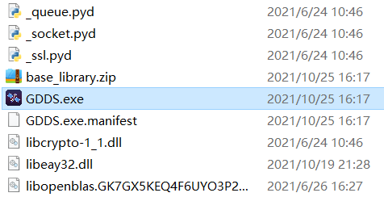

**Fig. 2.1** Example of executable file storted in “\GDDS\bin\Windows\GDDS.exe”

After double-clicking “GDDS.exe”, the software will start to run. The main interface of the software is shown in Fig. 2.2.

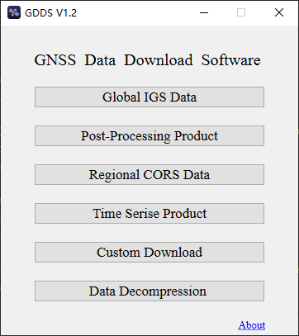

**Fig. 2.2** Software main interface

## 2.3 Module Introduction

GDDS consists of six modules, i.e., Global IGS data, Post-Processing Product, Regional CORS data, Time Series Product, Custom Download, and Data Decompression. Among them, the first four modules are used to download various GNSS data and products shown in Table 1. “Custom Download” module can execute the download link of user-defined configuration. The last module supports batch decompression of UNIX compressed files (with Z, gz as extensions) and CRINEX files (with d, crx as extensions).

**Table 1** Download content corresponding to different modules of GDDS

|  |  |  |
| --- | --- | --- |
| **Module** | **Download source** | **File type** |
| Global IGS data | 1.WHU (China)  2.IGN (France)  3.ESA (Europe)  4.KASI (Korea)  5.SIO (USA)  6.CDDIS (USA) | 1.RINEX 2.11/3.xx observation data (o/mo)  2.RINEX 2.11/3.xx meteorology data (m/mm)  3.RINEX 2.xx/3.xx navigation data (n/mn) |
| Post-Processing Product | 1.IGS  2.JPL (USA)  3.MIT (USA)  4.ESA (Europe)  5.GRG (France)  6.CAS (China)  7.UPC (Spain)  8.CODE (Switzerland)  9.SIO (USA)  10.NGS (USA)  11.EMR (Canada)  12.GFZ (Germany)  13.WHU (China) | 1.Precise ephemeris (sp3/eph)  2.Precise clock (clk)  3.Satellite yaw information (yaw)  4.Earth rotation parameters (erp)  5.Satellite attitude information (obx)  6.Antenna phase center model (atx)  7.Troposphere (tro/zpd)  8.Ionospheric-spherical harmonic model (ion)  9.Global ionosphere maps (i)  10.Rate of TEC index (f)  11.Differential code bias (dcb)  12.OSB Bias-SINEX (bia)  13.REL Bias-SINEX (bia)  14.DCB Bias-SINEX (bsx)  15.Daily/Weekly solution (snx) |
| Regional CORS data | 1.USA CORS  2.Europe EPN  3.Spain CORS  4.Japan JPN  5.HongKong CORS  6.Curtin University  7.Australia APREF | 1.RINEX 2.11/3.xx observation data (o/mo)  2.RINEX 2.11/3.xx meteorology data (m/mm)  3.RINEX 2.xx/3.xx navigation data (n/mn)  4.Partial products |
| Time Series Product | 1.EQDSC (China)  2.NGL (USA)  3.SOPAC (USA)  4.UNAVCO (USA)  5.IERS (Global) | 1.Combine time series (tar)  2.Time series (txt)  3.Residue time series (dat)  4.IGS14_XYX (txyz2)  5.IGS14_NEU (tenv3) |

# 

# 3 Operation Module

## 3.1 “Global IGS data” Module

The “Global IGS data” module mainly downloads GNSS data provided by the IGS data centers. You can click the “Global IGS data” button in the GDDS main interface to run this module. The “Global IGS data” operation interface is shown in Fig. 3.1.

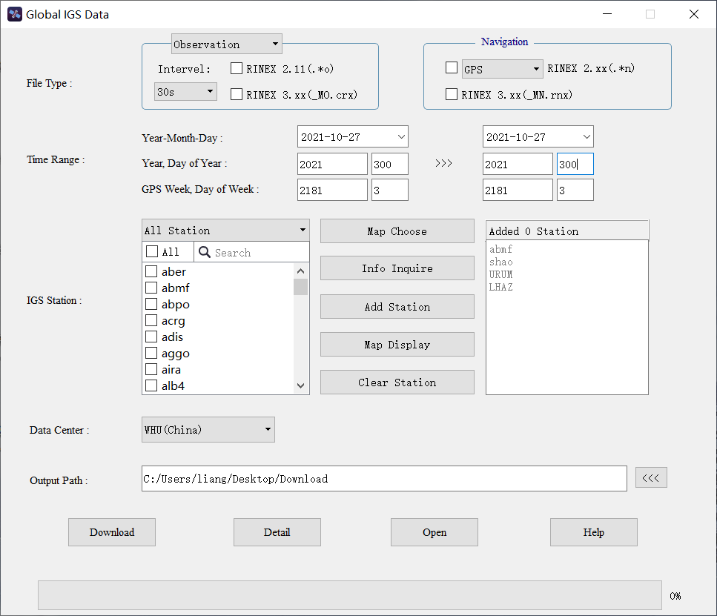

**Fig. 3.1** “Global IGS data” operation interface

### 3.1.1 File Type

The file types supported in this module are mainly observation data, navigation data, and meteorology data of RINEX version 2.11 and 3. xx provided by the IGS data center. You can choose to download one or more file types as needed. Since observation data and meteorology data are related to IGS stations, the corresponding IGS station needs to be added in the subsequent process when this file type is selected.

### 3.1.2 Time Range

Then set the start and end time corresponding to the download file. You can select one of any three different modes to express time, such as Year-Month-Day (Year-Month-Day Hour-Minute, Year-Month-Day Hour), Year with DOY, GPS week with Day of week. The software will automatically switch to the other two according to the input mode, which is convenient for users. It should be noted that the data released by IGS has a certain lag, so when setting the start and end time, you can move forward slightly at the current time.

### 3.1.3 IGS Station

When the observation data or meteorology data is selected in the file type, it is also necessary to choose and add the corresponding IGS station. The interface of the IGS station is illustrated in Fig. 3.2 below.

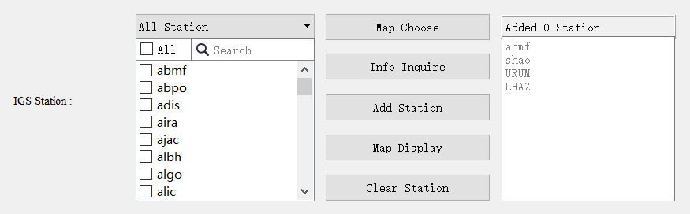

**Fig. 3.2** IGS station interface

On the left is the text box for searching and selecting the target IGS station. Stations displayed in this session will be updated in real-time according to the file type in order to ensure effectiveness and correctness. If you have specific requirements for the IGS station name, you can search for the station name based on this part and select the corresponding station name.

The text box on the right is a collection of the selected station information. The corresponding station for the final data download should be subject to the one shown in this part. You can add, modify and delete station information in here.

In the middle are some function buttons. The “Map Choose” button can open the map interaction function, which not only displays the global distribution of IGS stations but also supports a variety of interactive functions, such as single station selection, frame selection (i.e., rectangle, polygon, and circle), distance measurement, area calculation, etc. IGS map interactive function is exhibited in Fig. 3.3.

The “Info Inquire” button will generate the station information table, which is used to query some basic information of the IGS station, such as coordinates (longitude and latitude), receiver type, antenna type, etc, and support the operation of modifying, adding, deleting, exporting, saving and restoring the content of the station information table. IGS information retrieval function is displayed in Fig. 3.4.

The “Add Station” button can add the selected station on the left to the text box on the right. The “Map Display” button displays the selected stations in the right-hand text box on the map. The “Clear Station” is to quickly clear all stations in the text box on the right.

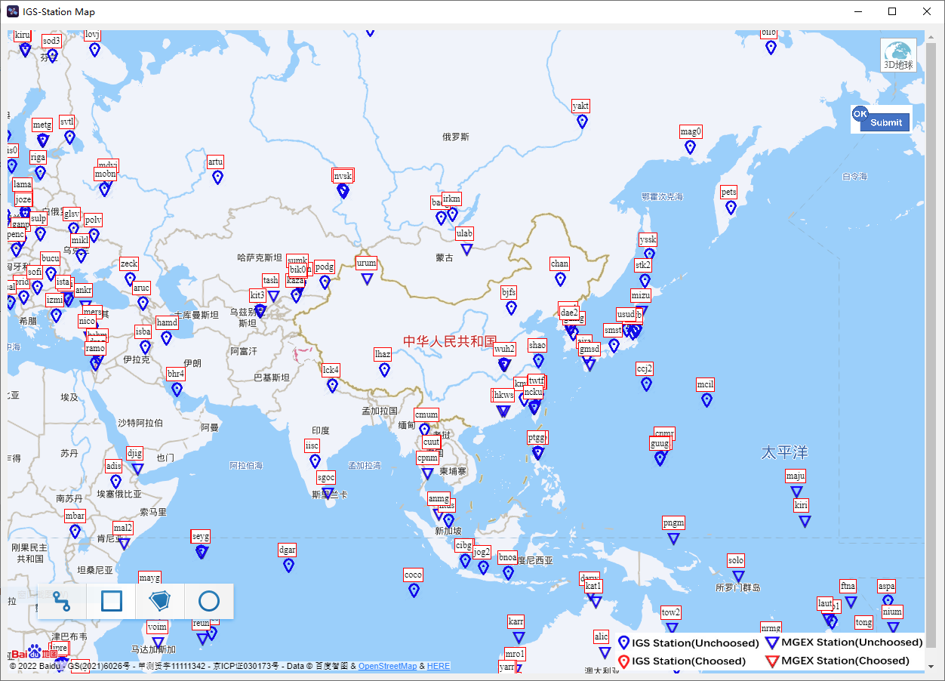

**Fig. 3.3** IGS map interactive function interface

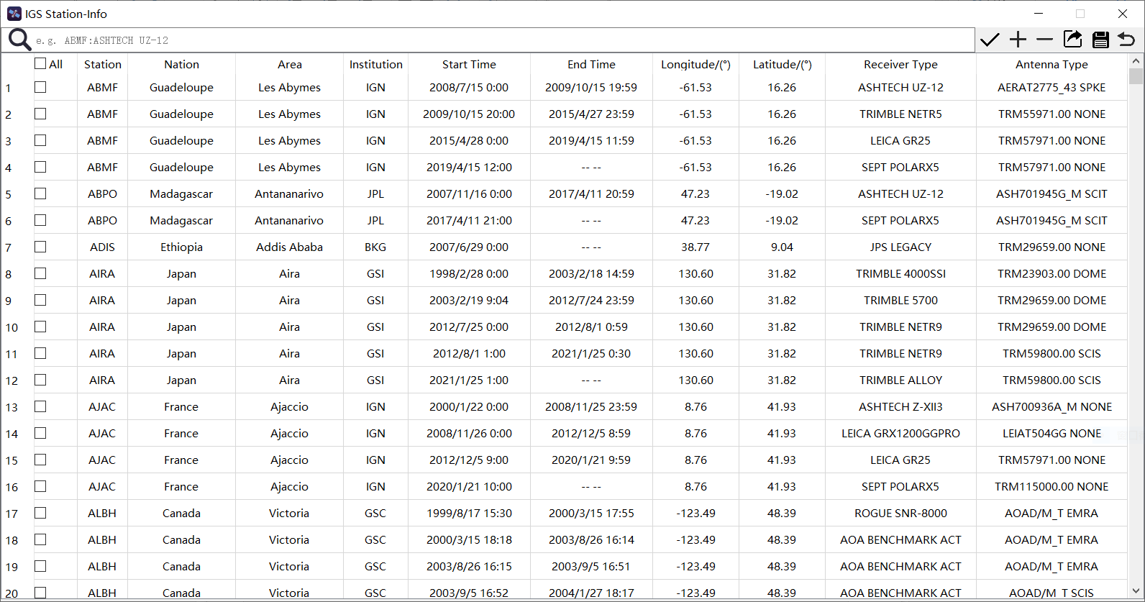

**Fig. 3.4** IGS information retrieval function interface

### 3.1.4 Data Center

The download sources supported by this module are six global data centers of IGS, namely WHU in China, IGN in France, ESA in Europe, CDDIS in the United States, SIO in the United States, and KASI in Korea. Users from different countries can choose the appropriate data center here to achieve the best download speed.

### 3.1.5 Output Path

Finally, select the output path of the download file. The default output path is the “Download “ folder on the computer desktop. You can also set other output paths as needed. Note that if the output path does not exist in the computer, the software will automatically create a corresponding folder according to the input path.

### 3.1.6 Function Button

There is a row of function buttons at the bottom of the module, namely “Download”, “Detail”, “Open” and “Help”. The “Download” button is used to start the download task. The “detail” button aims to open the log file of the entire download task, which also contains the analysis of the failure download task. The “Open” button can be devoted to conveniently the download folder open. The “Help” button is to quickly open the “GDDS User Manual” file.

## 3.2 “Post-Processing Product” Module

The “Post-Processing Product” module mainly downloads GNSS products provided by the IGS analysis center and other relevant data computation institutions. You can click the “Post-Processing Product” button in the GDDS main interface to run the module. The interface of this module is shown in Fig. 3.5.

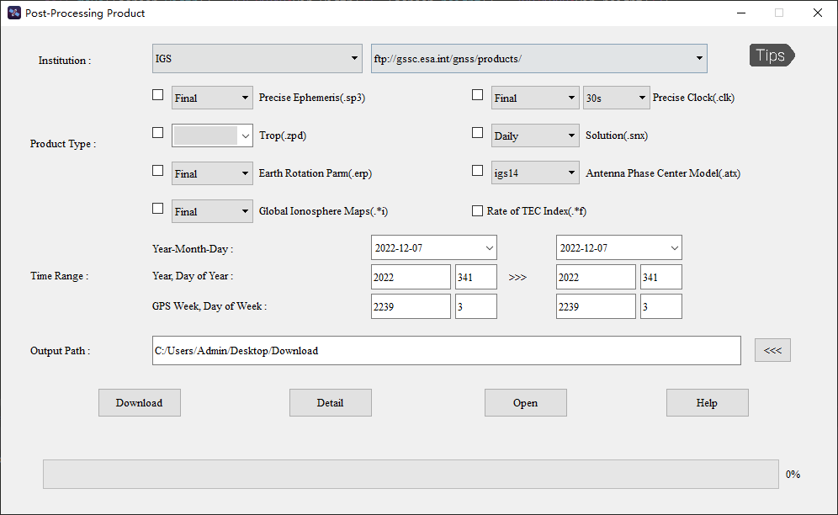

**Fig. 3.5** “Post-Processing Product” operation interface

### 3.2.1 Institution

Different institutions have their own post-processing products, which can be found on their own websites as well as on the websites of other institutions for data sharing reasons. Therefore, in the post-processing product module, users can choose different websites to download products. The URLs supported by different institutions are shown in Table 2.

**Table 2** Available URLs for products provided by different institutions

|  |  |
| --- | --- |
| Institution | URL |
| IGS | ftp://gssc.esa.int/gnss/products/  ftp://igs.gnsswhu.cn/pub/gps/products/  ftp://gdc.cddis.eosdis.nasa.gov/pub/gps/products/  ftp://igs.ensg.ign.fr/pub/igs/products/  ftp://nfs.kasi.re.kr/gps/products/  http://garner.ucsd.edu/pub/products/ |
| CODE | <http://ftp.aiub.unibe.ch/>  ftp://gssc.esa.int/gnss/products/  ftp://igs.gnsswhu.cn/pub/gps/products/  [ftp://gdc.cddis.eosdis.nasa.gov/pub/gps/products/](https://cddis.nasa.gov/archive/gps/products/)  <ftp://igs.ensg.ign.fr/pub/igs/products/>  ftp://nfs.kasi.re.kr/gps/products/  http://garner.ucsd.edu/pub/products/ |
| CAS | ftp://182.92.166.182/product/  ftp://ftp.gipp.org.cn/product/  ftp://gssc.esa.int/gnss/products/  ftp://igs.gnsswhu.cn/pub/gps/products/  ftp://gdc.cddis.eosdis.nasa.gov/pub/gps/products/  ftp://igs.ensg.ign.fr/pub/igs/products/ |
| WHU | ftp://igs.gnsswhu.cn/pub/gps/products/  ftp://igs.gnsswhu.cn/pub/whu/  <ftp://gssc.esa.int/gnss/products/>  ftp://gdc.cddis.eosdis.nasa.gov/pub/gps/products/  ftp://igs.ensg.ign.fr/pub/igs/products/ |
| GFZ | <ftp://ftp.gfz-potsdam.de/GNSS/products/>  ftp://gssc.esa.int/gnss/products/  ftp://igs.gnsswhu.cn/pub/gps/products/  ftp://gdc.cddis.eosdis.nasa.gov/pub/gps/products/  <ftp://igs.ensg.ign.fr/pub/igs/products/>  ftp://nfs.kasi.re.kr/gnss/products/  http://garner.ucsd.edu/pub/products/ |
| ESA | ftp://gssc.esa.int/gnss/products/  ftp://igs.gnsswhu.cn/pub/gps/products/  ftp://gdc.cddis.eosdis.nasa.gov/pub/gps/products/  <ftp://igs.ensg.ign.fr/pub/igs/products/>  <ftp://nfs.kasi.re.kr/gps/products/>  http://garner.ucsd.edu/pub/products/ |
| JPL | <ftp://gssc.esa.int/gnss/products/>  <ftp://igs.gnsswhu.cn/pub/gps/products/>  ftp://gdc.cddis.eosdis.nasa.gov/pub/gps/products/  ftp://igs.ensg.ign.fr/pub/igs/products/  <ftp://nfs.kasi.re.kr/gps/products/>  http://garner.ucsd.edu/pub/products/ |
| MIT | ftp://gssc.esa.int/gnss/products/  ftp://igs.gnsswhu.cn/pub/gps/products/  ftp://gdc.cddis.eosdis.nasa.gov/pub/gps/products/  ftp://igs.ensg.ign.fr/pub/igs/products/  <ftp://nfs.kasi.re.kr/gps/products/>  http://garner.ucsd.edu/pub/products/ |
| GRG | ftp://gssc.esa.int/gnss/products/  ftp://igs.gnsswhu.cn/pub/gps/products/  ftp://gdc.cddis.eosdis.nasa.gov/pub/gps/products/  ftp://igs.ensg.ign.fr/pub/igs/products/  <ftp://nfs.kasi.re.kr/gps/products/> |
| EMR | ftp://rtopsdata1.geod.nrcan.gc.ca/gps/products/  ftp://gssc.esa.int/gnss/products/  ftp://igs.gnsswhu.cn/pub/gps/products/'  ftp://gdc.cddis.eosdis.nasa.gov/pub/gps/products/  ftp://igs.ensg.ign.fr/pub/igs/products/  ftp://nfs.kasi.re.kr/gps/products/ |
| SIO | [http://garner.ucsd.edu/pub/products/](ftp://lox.ucsd.edu/pub/products/)  <ftp://gssc.esa.int/gnss/products/>  ftp://igs.gnsswhu.cn/pub/gps/products/  ftp://gdc.cddis.eosdis.nasa.gov/pub/gps/products/  <ftp://igs.ensg.ign.fr/pub/igs/products/>  ftp://nfs.kasi.re.kr/gps/products/ |
| NGS | ftp://gssc.esa.int/gnss/products/  ftp://igs.gnsswhu.cn/pub/gps/products/  ftp://gdc.cddis.eosdis.nasa.gov/pub/gps/products/  <ftp://igs.ensg.ign.fr/pub/igs/products/>  ftp://nfs.kasi.re.kr/gps/products/ |
| UPC | ftp://gssc.esa.int/gnss/products/  <ftp://igs.gnsswhu.cn/pub/gps/products/>  ftp://gdc.cddis.eosdis.nasa.gov/pub/gps/products/ |

### 3.2.2 Product Type

The product types supported by this module include precise ephemeris (.sp3/.eph), precise clock (.clk), satellite yaw information (.yaw), earth rotation parameters (.erp), satellite attitude information (.obx), antenna phase center model (.atx), troposphere (.tro/.zpd), ionospheric spherical harmonic model (.ion), global ionosphere maps (.i), rate of TEC index (.f), differential code bias (.dcb), bias-SINEX (.bia), and daily/weekly solution (.snx). There are differences in the types of products provided by different institutions (Tips: G/R is GPS/GLONASS, MGEX is multi-GNSS, and unstatement is GPS/GLONASS).

### 3.2.3 Time Range

Similarly, set the start and end time corresponding to the download file. As mentioned above, you can select any one of the three modes to express time, and then the software will automatically realize time conversion. Please note that those products provided by institutions have a certain lag, so it is suggested to move forward slightly at the current time when setting the start and end times.

### 3.2.4 Output Path

Choose the output path of the download files. The default output path is the “Download” folder on the computer desktop. You can also set another output path as required. When the output path does not exist in the computer, the software will automatically create the corresponding folder according to the input path.

### 3.2.5 Function Button

There is a row of function buttons below this module, namely “Download”, “Detail”, “Open”, and “Help”. Each function is similar to the previous section.

## 3.3 “Regional CORS Data” Module

The “Regional CORS Data” module mainly downloads GNSS data and partial products provided by CORS. You can click the “Regional CORS Data” button in the GDDS main interface to run this module. The interface of this module is shown in Fig. 3.6.

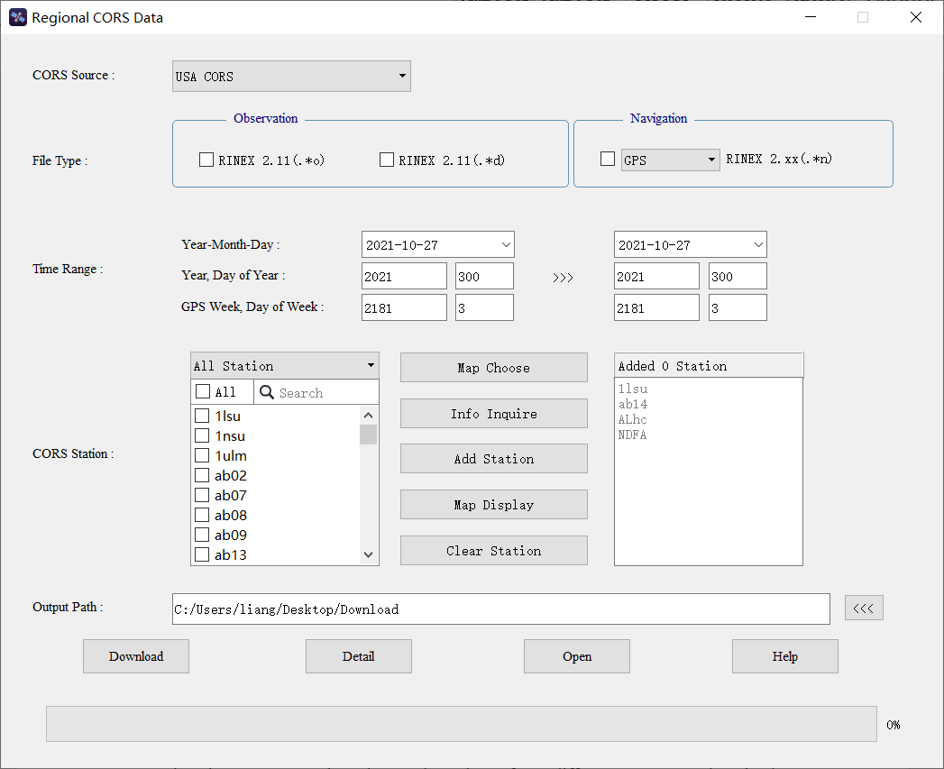

**Fig. 3.6** “Regional CORS Data” operation interface

### 3.3.1 CORS Source

The download sources supported by this module are CORS, namely American CORS, Australian APREF, European EPN, Spanish CORS, Hong Kong CORS, and Curtin University. You can select data and products from different CORS to download according to your needs.

### 3.3.2 File Type

The file types supported by this module include observation data, navigation data, meteorology data, and some products (such as precise ephemeris, precise clock, small cycle slip, and weekly solution). Different CORS provides different file types.

### 3.3.3 Time Range

As is stated above, you can set the start and end time in any of three ways, and then the software automatically realizes time transformation. It should be noted that those data provided by CORS have a certain lag, so when setting the start and end time, please move forward slightly at the current time.

### 3.3.4 CORS Station

When selecting the observation or meteorology data, you also need to choose and add the corresponding CORS station. The interface design of the CORS station is divided into three parts, as shown in Fig. 3.7.

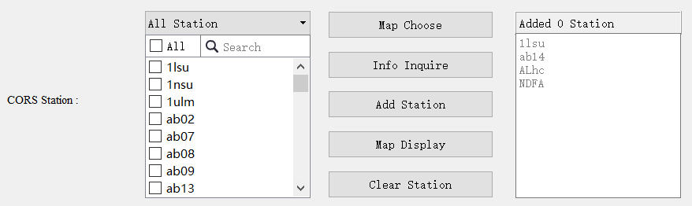

**Fig. 3.7** CORS station interface display

On the left is the text box for searching and selecting the target CORS station. Stations displayed here will be updated in real-time based on the selected file type and the CORS source. When you have specific requirements for CORS station name, you can search for the station name and then select the corresponding station.

The text box on the right is a summary of the added CORS station information. The corresponding station for the final data download should be according to the one shown in this part, and it can also be added, modified, and deleted in here.

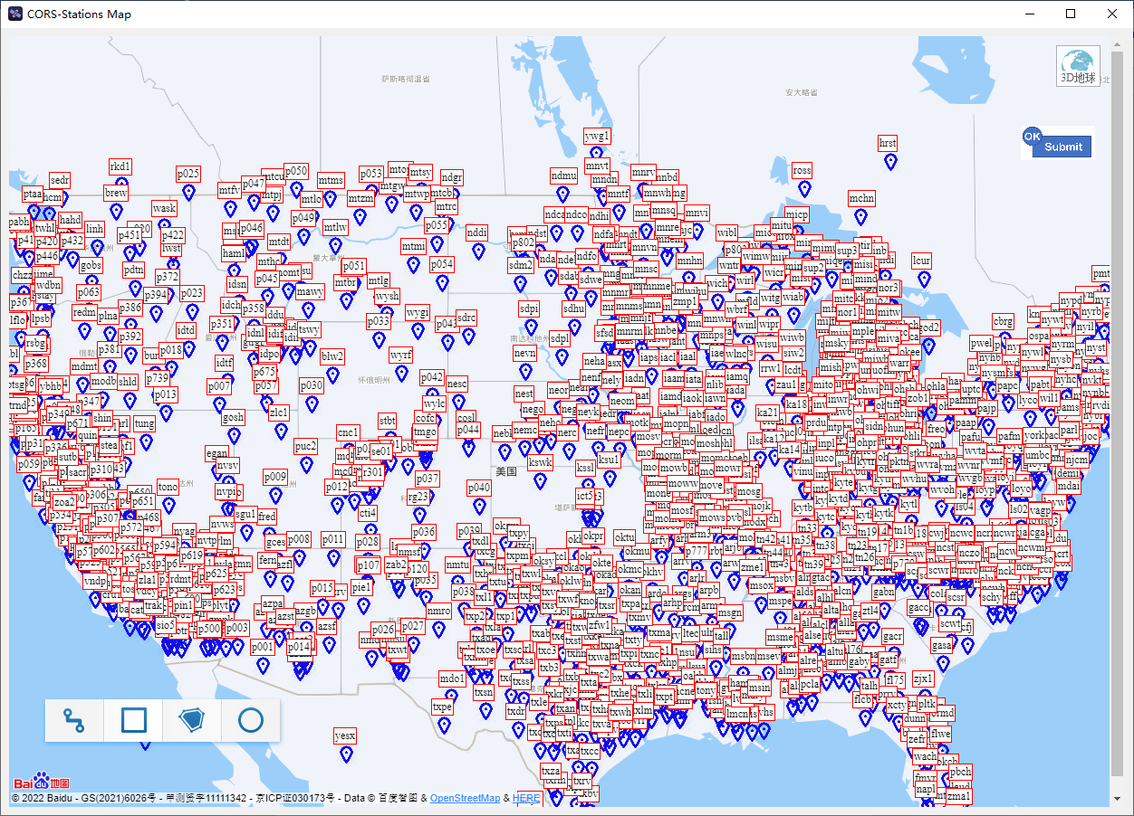

**Fig. 3.8** American CORS map interactive function interface

In the middle are some function buttons. The “Map Choose” button can implement the map interaction function, which not only shows the global distribution of CORS stations but also supports various interactive functions, such as single station selection, frame selection (namely rectangle, polygon, circle), distance measurement, area calculation, etc. Take the American CORS map interactive function as an example, as exhibited in Fig. 3.8.

The “Info Inquire” button can create the station information table to query some basic information of the CORS station, such as the station coordinates (longitude and latitude), receiver type, and antenna type, and support the operation of modifying, adding, deleting, exporting, saving and restoring the content of the station information table. Take the American CORS information retrieval function as an example, and the software interface is displayed in Fig. 3.9.

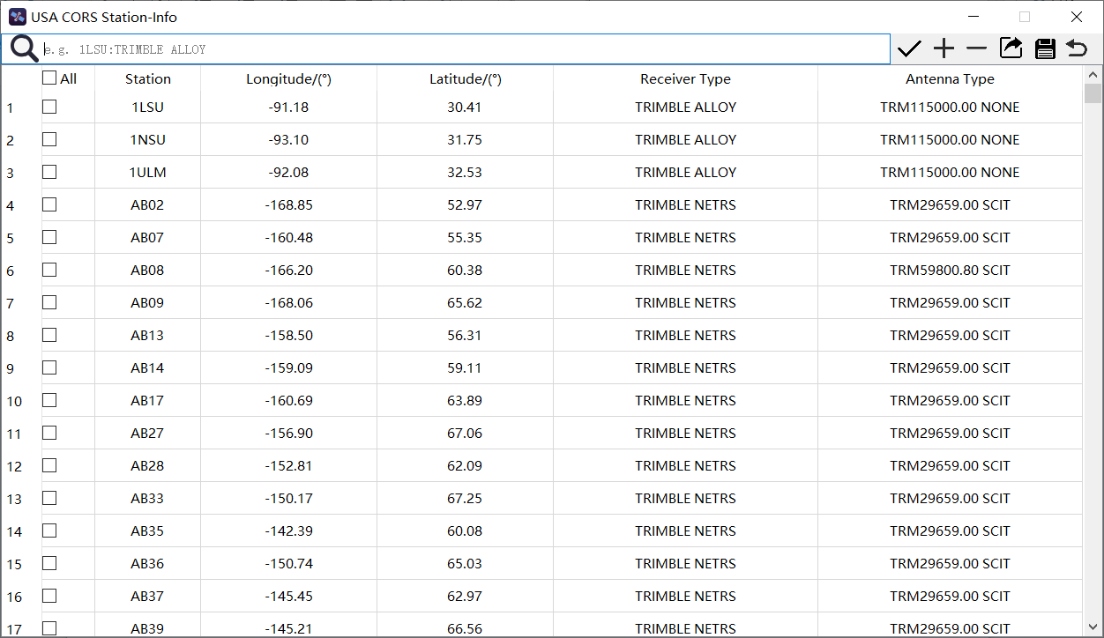

**Fig. 3.9** American CORS information retrieval function interface

The “Add Station” button adds the selected station on the left to the text box on the right. The “Map Display” button intuitively displays CORS stations in the right-hand text box on the map. The “Clear Station” is to quickly clear all stations in the text box on the right.

### 3.3.5 Output Path

As commented earlier, you can use the default output path on the computer desktop or set another appropriate output path.

### 3.3.6 Function Button

Function buttons at the bottom of this module are the same as described above, not tired in words here.

## 3.4 “Time Series Product” Module

The “Time Series Product” module mainly downloads GNSS time series product provided by some research institutions. You can click the “Time Series Product” button in the GDDS main interface to run the module. The interface of this module is shown in Fig. 3.10.

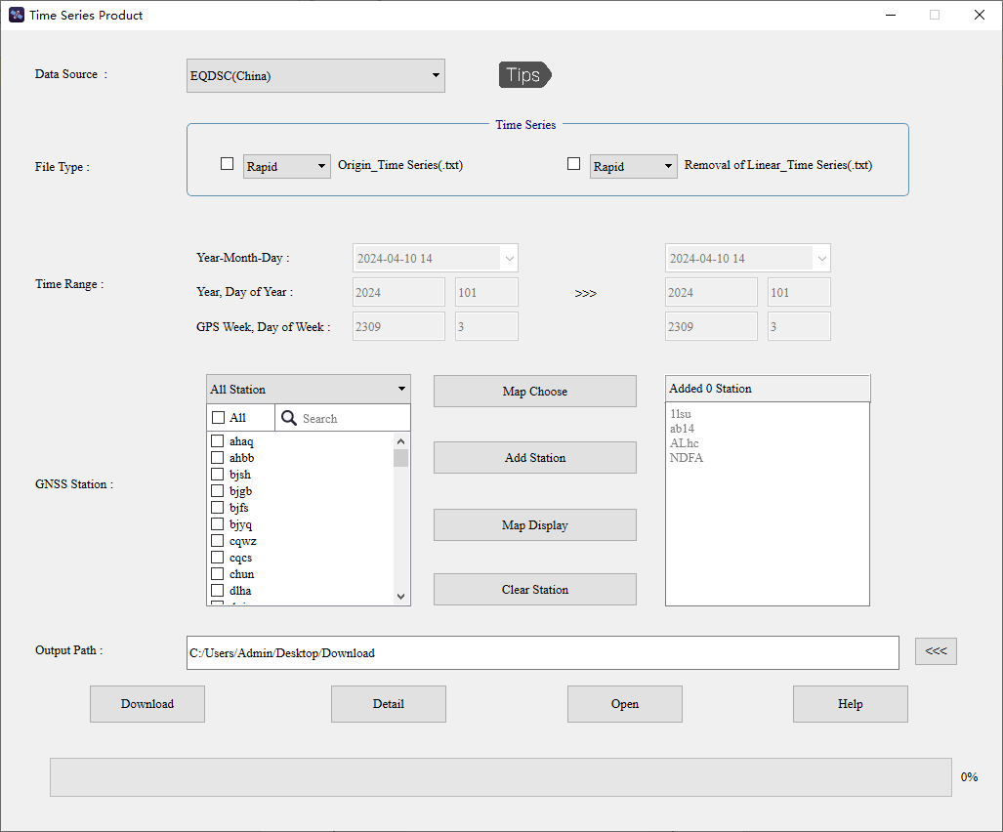

**Fig. 3.10** “Time Series Product” operation interface

### 3.4.1 Institution

The download sources supported by this module are China EQDSC, USA NGL, USA SOPAC, USA UNAVCO, and IERS. You can select data and products from different research institutions to download according to your needs. The URLs supported by different institutions are shown in Table 3.

**Table 3** Available URLs for time series products provided by different institutions

|  |  |
| --- | --- |
| Institution | URL |
| EQDSC | https://www.eqdsc.com/eastern/upload/gnss/kssjxl/ys/ |
| NGL | <http://geodesy.unr.edu/gps_timeseries/>  http://geodesy.unr.edu/tsplots/ |
| SOPAC | ftp://sopac-ftp.ucsd.edu/pub/timeseries/measures/ |
| UNAVCO | https://geodesy.noaa.gov/corsdata/coord/ |
| IERS | https://itrf.ign.fr/ftp/pub/itrf/ |

### 3.4.2 File Type

The file types supported by this module include combine time series, time series, residue time series, IGS14_XYX, and IGS14_NEU. Different research institutions provide different file types.

### 3.4.3 Time Range

As is stated above, you can set the start and end time in any of three ways, and then the software automatically realizes time transformation. It should be noted that those data provided by research institutions have a certain lag, so when setting the start and end time, please move forward slightly at the current time.

### 3.4.4 Station

When downloading time series products, some institution's sources must also add station information.

### 3.4.5 Output Path

As commented earlier, you can use the default output path on the computer desktop or set another appropriate output path.

### 3.4.6 Function Button

Function buttons at the bottom of this module are the same as described above, not tired in words here.

## 3.5 “Custom Download” Module

The “Custom Download” module mainly realizes the download of data according to the download link configured by the user. You can click the “Custom Download” button on the main interface of GDDS to start the module. The interface of this module is shown in Fig. 3.11.

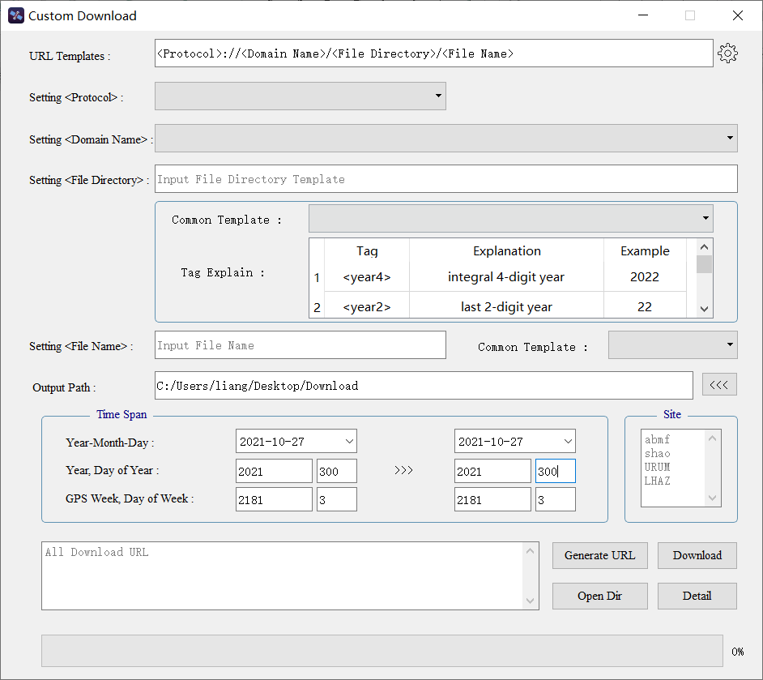

**Fig. 3.11** “Custom Download” operation interface

### 3.5.1 URL Templates

Display the actual details of the self-configured URL in real time, and open the information setting interface through the “Settings” button to modify, add, delete and restore it..

### 3.5.2 Setting Protocol

Select the protocol type corresponding to the target data transmission. There are mainly three protocol types: ftp, http and https.

### 3.5.3 Setting Domain Name

Select or add the domain name of the server where the target data is stored.

### 3.5.4 Setting File Directory

Enter the specific storage path of the target data in the server. When the path contains variables such as time and station name, you need to refer to the label for input. For details of the supported labels, see “Label Explanation” at the bottom of the software.

### 3.5.5 Setting File Name

Enter the file name corresponding to the target data. For the convenience of users, the file names of most file types are provided in “Common Template”, including RINEX V3, RINEX V2 and Product. The explains of common template of file name are listed in Table 4.

**Table 4** The explains of common template of file name

|  |  |  |
| --- | --- | --- |
| **File name template** | **Letters** | **Meaning** |
| <SITE>RNCRC_S_<year4><doy>  HRMN_LEN_FRQ_ST.FMT | RN | The number of the receiver; |
| CRC | A three-digit ISO-3166-1 standard country code that identifies the site location; |
| S | Data source, that is, the data comes from the receiver (R) or the data stream (S); |
| HRMN | Observation start time: hour, minute; |
| LEN | The length of the observation period; |
| FRQ | Sampling interval or sampling frequency during observation (no such item in ephemeris file); |
| ST | Included satellite system and data type, the first digit indicates the satellite system (M, G, R, C, E, J, I); the second digit is the data type, namely observation file (O), navigation file (N) or Meteorological file (M); |
| FMT | There are only two types of extensions: rnx or crx; |
| <site><doy>#.<year2>t | # | 1 bit, when there are multiple files in a day, it indicates the number of files in a day. Usually 0 means all data for a day (one file); |
| t | type of data; |
| AAA<week><dow>.TYP | AAA | The name of analysis center; |
| TYP | type of solution; |

### 3.5.6 Output Path

Select the output path for the downloaded file. The default output path is the Downloads folder on your computer desktop. You can also set to other output paths as needed. Tip: When the folder displayed in the text box does not exist on the computer, the software will automatically create the folder.

### 3.5.7 Time Span and Site

Set the time corresponding to the time tag in the download link. You can set three time formats: year-month-day, year-year cumulative day, GPS week and day of the week, the software will automatically convert the other two times according to the time you input, and customize the time in the download link The label is replaced with a specific time.

Set the specific station corresponding to the station label in the download link. This action is not required when the configured download link does not contain a station tag.

### 3.5.8 Function Button

There are some function buttons under the module, namely “Generate URL”, “Download”, “Open Dir” and “Detail”. “Generate URL” is to generate a specific URL according to the various information configured in the above steps, and the generated URL will be loaded and displayed in the left text box; “Download” is to execute the download task corresponding to the URL in the left text box of the button; “Open Dir” is to switch the output path of the open file; “Detail” is to view the execution of the task.

## 3.6 “Data Decompression” Module

The “Data Decompression” module supports the decompression of GNSS data and products. Based on this module, UNIX compressed files (with Z, gz as extensions) and CRINEX files (with d, crx as extensions) can be decompressed in batch with “one-click”.